Architectural Review Checklist

caMOD
2.1

Revision Document History
Date | Version | Description | Author
09/10/03 | 1.0 | First draft | NCICB Dedicated Support
11/07/03 | 1.0 | Final version 1.0. | NCICB Dedicated Support
05/12/04 | 2.0 | Redesign to incorporate developer answer phase followed by a systems interview phase. | NCICB Dedicated Support

Table of Contents
1. Introduction 6
1.1 Purpose 6
1.2 Guidelines for Completing the ARC 6
2. Project Details (To be answered by development team) 6
2.1 General Information 6
2.1.1 Project Description 6
2.1.2 Contact Information 6
2.1.3 Major Deployment Milestones 6
2.2 Architectural Details 7
2.2.1 High level architectural description: 7
2.2.2 High Level Design Diagram (If available): 7
2.2.3 Implementation language(s) used? 7
2.2.4 Will connections/requests to the application be session based (i.e. statefull versus stateless)? If so, is there any reason why application would not support “sticky session” load balancing? 7
2.2.5 Will the application be caching data? If so, what is being cached and how much data will be cached? 7
2.2.6 What data files will be created (if any)? How much data will be saved on an on going basis? 7
2.2.7 Will this application need a database schema(s) created on the NCICB infrastructure? If so, what is the maximum number of objects to be stored? 7
2.2.8 Are there any external/non-NCICB data sources that will be accessed by the application? 7
2.2.9 If this is a web-based application, what are the preferred virtual hosts names to be registered? 7
2.2.10 Any additional architectural details that may be of significance to the needed deployment environment. 7
2.3 Performance Requirements 8
2.3.1 Total number of users for this application? 8
2.3.2 Peak number of concurrent users? 8
2.3.3 Peak number of requests/minute? 8
2.3.4 Up time requirements? 8
2.3.5 Acceptable down time when recovering from major systems disaster? 8
2.4 NCICB Project Dependencies 8
2.5 Configuration Management Details 8
2.5.1 Version Control 8
2.5.2 Change Control 8
2.5.3 Migration to CVS 8
2.5.4 Users 8
2.5.5 Build Process 8
2.5.6 Other CM Needs 8
2.6 Additional Notes 8
3. System Requirements (To be answered by both development & systems team) 9
3.1 Operating System 9
<<Solaris/LINUX/Windows 2000/…>> 9
3.2 Software (Technology Stack) 9
3.2.1 Web Server: <<Apache/Tomcat/ZOPE/…>> 9
3.2.2 App Server: <<Tomcat/JBoss/Oracle 9iAS/…>> 9
3.2.3 Database Server: <<Oracle/MySQL/PostgreSQL/…>> 9
3.2.4 Other software components: <<PERL x.x, Python x.x, …>> 9
3.3 Server Hardware 9
3.3.1 Server: <<type, model, …>> 9
3.3.2 Minimum processor speed: 9
3.3.3 Minimum memory: 9
3.3.4 Minimum local drive space: 9
3.4 Storage 9
3.4.1 Expected file server disk storage (in MB): 9
3.4.2 Expected database storage (in MB): 9
3.4.3 Expected ftp storage (in MB): 9
3.4.4 Expected media/image storage (in MB): 9
3.5 Load Balancing/Fault Tolerance 9
3.5.1 Does the application support load balancing? 9
3.5.2 Implement load balancing – YES/NO 9
3.6 Networking 9
3.6.1 Any application specific port assignments? 9
3.6.2 Any additional configuration? 9
3.7 Additional Notes 9
4. Proposed NCICB Deployment Environment (To be answered by systems team) 9
4.1 Hardware 9
4.2 Technology Stack 10
4.3 File Server 10
4.4 Database 10
4.5 Networking 10
4.6 Other Resources 10
5. Impact Assessment (To be answered by systems team) 10
5.1 Overview 10
5.2 Cost 10
5.3 Timeline to implement 10
5.4 Additional Notes 10
6. Acceptance 10
7. Appendix 1 - Future Systems Requirements 11
7.1 New Architecture Diagram 11
7.2 Notes on the design change 11
7.3 Hardware 11
7.3.1 Servers 11
7.3.2 Processor speed 11
7.3.3 Memory 11
7.3.4 Drive Space 11
7.4 Software (Technology Stack) 11
7.4.1 Web Server 11
7.4.2 App Server 11
7.4.3 Other components 11
7.5 Fault Tolerance (Redundancy) 11
7.5.1 Does the application support load balancing? 11
7.5.2 Implement load balancing – YES/NO 11
7.5.3 Load balancing requirements 11
7.5.4 Fault tolerance solution suggested 11
7.5.5 Additional requirements (if any) 11
7.6 Performance Enhancements 11
7.6.1 Processing Power 11
7.6.2 Memory 11
7.6.3 I/O 11
7.6.4 Other needs 11

Introduction

Purpose
The purpose of the Architectural Review Checklist (ARC) is to help identify the deployment environment (both hardware and software components) necessary for an application to execute optimally within the NCICB IT infrastructure. The ARC is considered to be a dynamic artifact for any NCICB project and should be maintained in the configuration library (i.e. CVS) for each project. For new projects, this document template will be automatically checked into the projects repository by the SCM team upon project initiation. The ARC should be reviewed on at least a quarterly basis to capture any application design changes that may effect the deployment environment necessary for optimal performance.

Guidelines for Completing the ARC
The ARC is divided into 4 main sections. The first section (Project Details) is meant to capture general information about the project. The project development team should fill out the Project Details section and return it to the systems team. The second section (Systems Requirements) is meant to capture details of specific system requirements for the project. Both the development and system teams will preferably answer the Systems Requirement section jointly. However, depending on the development teams familiarity with the NCICB infrastructure, they may choose to answer either all or parts of this section on their own. The third section (Planned Deployment Environment) specifies the proposed deployment environment for the application and is to be answered by the systems team based on the response to section 1 & 2. Finally, the last section (Impact Assessment) describes the impact (additional hardware/software costs, staffing resources…) to the existing NCICB IT infrastructure in order to support this application. Upon completion of the Deployment Environment and Impact Assessment sections, the systems team will return the ARC to the development team for final review and comments.

Project Details

General Information

Project Description
Next release of cancer models application. New functionality along with database cleanup/optimization. This release will also have a remote interface and a planned caGRID release.

Contact Information
Title | Name | Phone | Email
Project Manager | Srini Guruswami | 301-451-2211 | guruswamis@mail.nih.gov
Team Lead/Architect | David George | 301-594-4681 | georgeda@mail.nih.gov
SCM Coordinator | David George | 301-594-4681 | georgeda@mail.nih.gov

Major Deployment Milestones
Milestone | Date
Planned Release to QA | Early/Mid March, Early/Mid April, Early/Mid May (Three iterations)
Planned Release to Staging | Mid/Late May
Planned Release to Production | Early/Mid June

Architectural Details

High level architectural description:
N-tier Web application built using JSP/Struts and Hibernate. Front end presentation layer uses JSPs with struts/JSTL and custom tags. The controller layer is implemented using struts actions talking to the business logic layer through object manager classes which wrap the lower level domain classes. Access to the database is through domain classes mapped to database tables via Hibernate using the “Common Persistence” package. Some access to the database is through an SQL/HQL interface in the “Common Persistence” package for performance reasons.

High Level Design Diagram (If available):
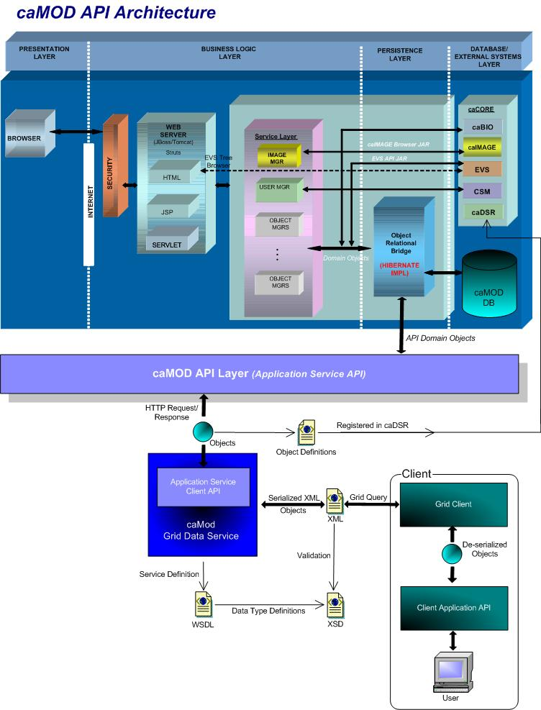

Implementation language(s) used?
Java, Html/JSTL tags for presentation layer.

Will connections/requests to the application be session based (i.e. statefull versus stateless)? If so, is there any reason why application would not support “sticky session” load balancing?

Connections are “statefull”. No known reason why sticky session load balancing cannot be used, but it would need to be thoroughly tested before production deployment.

Will the application be caching data? If so, what is being cached and how much data will be cached?

We cache a little bit of EVS data in the caMOD application. The display name for diseases and organs are cached to eliminate calls to caBIO. Option lists which are read from text files are also cached.
Neither of these are of significant size.

What data files will be created (if any)? How much data will be saved on an on going basis?

A nci-camod.log file is created for application logging. Currently this runs close to 20 megabytes per day, but this will go down as we will be reducing the logging level with the next release.

Will this application need a database schema(s) created on the NCICB infrastructure? If so, what is the maximum number of objects to be stored?

Yes. The current database has ~3-4 million rows of data. The large part of this was a one-time download of data. The database will have more data added, but for the 2.1 release it will not grow significantly.

Are there any external/non-NCICB data sources that will be accessed by the application?

We might be accessing the MGI database from Jackson Labs. It is undecided at this point if we will be importing data or simply using a JDBC interface to query.

If this is a web-based application, what are the preferred virtual hosts names to be registered?

cancermodels.nci.nih.gov

Any additional architectural details that may be of significance to the needed deployment environment.

Using CSM for authentication.
Using internal LDAP utility going to URL ldaps://ncids2b.nci.nih.gov:636

Performance Requirements

Total number of users for this application?

Current usage appears to be ~1000 unique IP’s into the system per month per web usage statistics.

Peak number of concurrent users?

Please look @ current web-usage statistics.

Peak number of requests/minute?

Please look @ current web-usage statistics.

Up time requirements?

Desired 7/24, but this is not a mission critical application, and I estimate that the general usage times will be 6 a.m. – 10 p.m.

Acceptable down time when recovering from major systems disaster?
24 hours.

NCICB Project Dependencies
caBIO, CSM, EVS, EVSTree, caIMAGE

Configuration Management Details
Briefly describe your current configuration management practices here.

Version Control
What version control software are you currently using, if any?
CVS

Change Control
What are your current change control practices? What procedures are in place to determine whether to implement a change request?

Migration to CVS
Indicate whether you will require SCM support migrating your source code to the NCICB CVS repository.
N/A

Users
Provide a list of all developers who require access to your repository modules.
David George
Ulli Wagner
Srini Guruswami
Nick Schroedl
Ajay Gupta
Marc Piparo

Build Process
Describe your build process here. For example, are you using Ant, Make, or something else?
Ant

Other CM Needs
Describe any other CM needs?

Additional Notes

System Requirements

Operating System

Solaris

Software (Technology Stack)

Web Server: Apache

App Server: JBoss 4.0.2

Database Server: Oracle

Other software components: Java 1.5.04

Server Hardware

Server: <<type, model, …>>

Minimum processor speed:

Minimum memory:

Minimum local drive space:

Storage

Expected file server disk storage (in MB):

Expected database storage (in MB):

Expected ftp storage (in MB): 0.0

Expected media/image storage (in MB):0.0

Load Balancing/Fault Tolerance

Does the application support load balancing? Not tested

Implement load balancing – YES, depending on results of testing.

Networking

Any application specific port assignments? NO

Any additional configuration? NO

Additional Notes

Proposed NCICB Deployment Environment (To be answered by systems team)

Hardware
<<dev, qa, staging, production servers to be used>>

Technology Stack
<<specific technology stack to be used>>

File Server
<<space allocation on big IP, NFS mount points, initial size allocation…>>

Database
<<database server to used, schema names to be created, initial size, maximum size…>>

Networking
<<e.g. any BigIP configuration necessary, …>>

Other Resources
<<e.g. ftp server access, media server access, …>>

Impact Assessment (To be answered by systems team)

Overview

Cost

Timeline to implement

Additional Notes

Acceptance
Project Lead ( ) | Project Coordinator – NCICB ( )
Systems Team | SCM Administrator

Appendix 1 - Future Systems Requirements
In this section, describe any projected future anticipated requirements for your system.

New Architecture Diagram

Notes on the design change

Hardware

Servers

Processor speed

Memory

Drive Space

Software (Technology Stack)

Web Server

App Server

Other components

Fault Tolerance (Redundancy)

Does the application support load balancing?

Implement load balancing – YES/NO

Load balancing requirements

Fault tolerance solution suggested

Additional requirements (if any)

Performance Enhancements

Processing Power

Memory

I/O

Other needs

